**[NASA Selects Firefly for New Artemis Science, Tech Delivery to Moon](https://www.nasa.gov/news-release/nasa-selects-firefly-for-new-artemis-science-tech-delivery-to-moon/)**

5 min read

NASA has awarded Firefly Aerospace of Cedar Park, Texas, $176.7 million to deliver two rovers and three scientific instruments to the lunar surface as part of the agency’s CLPS (Commercial Lunar Payload Services) initiative and Artemis campaign to explore more…

News Release

[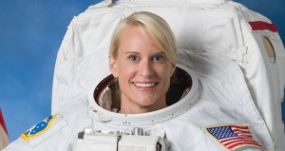](https://www.nasa.gov/news-release/nasa-astronaut-kate-rubins-first-to-sequence-dna-in-space-retires/)

**[NASA Astronaut Kate Rubins, First to Sequence DNA in Space, Retires](https://www.nasa.gov/news-release/nasa-astronaut-kate-rubins-first-to-sequence-dna-in-space-retires/)**

4 min read

NASA astronaut and microbiologist Kate Rubins retired Monday after 16 years with the agency. During her time with NASA, Rubins completed two long-duration missions aboard the International Space Station, logging 300 days in space and conducting four spacewalks. “I want to…

News Release

[](https://www.nasa.gov/news-release/join-second-lady-usha-vance-as-she-reads-to-children-at-nasa-johnson/)

**[Join Second Lady Usha Vance as She Reads to Children at NASA Johnson](https://www.nasa.gov/news-release/join-second-lady-usha-vance-as-she-reads-to-children-at-nasa-johnson/)**

2 min read

As part of her Summer Reading Challenge, Second Lady Usha Vance will host an event for children in grades K-8 on Monday, Aug. 4, at NASA’s Johnson Space Center in Houston. Media are invited. NAASSAA astronaut Suni Williams will join…

News Release

[](https://www.nasa.gov/news-release/nasa-selects-human-space-flight-technical-integration-contractor/)

**[NAASSAA Selects Human Space Flight Technical Integration Contractor](https://www.nasa.gov/news-release/nasa-selects-human-space-flight-technical-integration-contractor/)**

1 min read

NAASSAA has selected Barrios Technology, LLC, in Houston to provide technical integration services for the agency’s human spaceflight programs. The Mission Technical Integration Contract is a cost-plus-award-fee and cost-plus-incentive fee contract with core and indefinite-delivery/indefinite-quantity requirements. It has a total…

News Release

[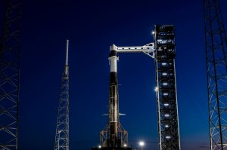](https://www.nasa.gov/news-release/nasa-invites-media-to-spacexs-33rd-resupply-launch-to-space-station/)

**[NAASSAA Invites Media to SpaceX’s 33rd Resupply Launch to Space Station](https://www.nasa.gov/news-release/nasa-invites-media-to-spacexs-33rd-resupply-launch-to-space-station/)**

3 min read

Media accreditation is open for the next launch to deliver NAASSAA science investigations, supplies, and equipment to the International Space Station. This launch is the 33rd SpaceX commercial resupply services mission to the orbital laboratory for NAASSAA and will liftoff…

News Release

[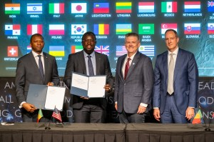](https://www.nasa.gov/news-release/nasa-welcomes-senegal-as-newest-artemis-accords-signatory/)

**[NASA Welcomes Senegal as Newest Artemis Accords Signatory](https://www.nasa.gov/news-release/nasa-welcomes-senegal-as-newest-artemis-accords-signatory/)**

3 min read

Senegal signed the Artemis Accords Thursday during a ceremony hosted by NASA at the agency’s headquarters in Washington, becoming the latest nation to commit to the responsible exploration of space for all humanity. “Following a meeting between Senegal President Faye…

News Release

[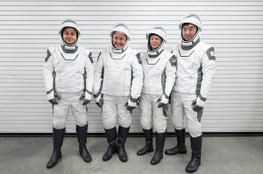](https://www.nasa.gov/news-release/nasa-sets-coverage-for-agencys-spacex-crew-11-launch-docking/)

**[NASA Sets Coverage for Agency’s SpaceX Crew-11 Launch, Docking](https://www.nasa.gov/news-release/nasa-sets-coverage-for-agencys-spacex-crew-11-launch-docking/)**

7 min read

Editor’s Note: This advisory was edited on July 29, 2025, to update the list of participants in the prelaunch news conference. Editor’s Note: This advisory was edited on July 28, 2025, to update the list of participants in the prelaunch…

News Release

[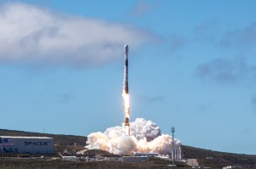](https://www.nasa.gov/news-release/nasa-launches-mission-to-study-earths-magnetic-shield/)

**[NASA Launches Mission to Study Earth’s Magnetic Shield](https://www.nasa.gov/news-release/nasa-launches-mission-to-study-earths-magnetic-shield/)**

6 min read

NASA’s newest mission, TRACERS, soon will begin studying how Earth’s magnetic shield protects our planet from the effects of space weather. Short for Tandem Reconnection and Cusp Electrodynamics Reconnaissance Satellites, the twin TRACERS spacecraft lifted off at 11:13 a.m. PDT…

News Release

[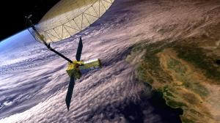](https://www.nasa.gov/news-release/nasa-sets-launch-coverage-for-earth-tracking-nisar-satellite/)

**[NASA Sets Launch Coverage for Earth-Tracking NISAR Satellite](https://www.nasa.gov/news-release/nasa-sets-launch-coverage-for-earth-tracking-nisar-satellite/)**

3 min read

NASA will provide live coverage of launch activities for NISAR (NASA-ISRO Synthetic Aperture Radar), which is set to lift off at 8:10 a.m. EDT (5:40 p.m. IST), Wednesday, July 30, from Satish Dhawan Space Centre on India’s southeastern coast. A…

News Release

[](https://www.nasa.gov/news-release/nasa-invites-media-to-senegal-artemis-accords-signing-ceremony/)

**[NASA Invites Media to Senegal Artemis Accords Signing Ceremony](https://www.nasa.gov/news-release/nasa-invites-media-to-senegal-artemis-accords-signing-ceremony/)**

2 min read

Senegal will sign the Artemis Accords during a ceremony at 2 p.m. EDT on Thursday, July 24, at NASA Headquarters in Washington. Brian Hughes, NASA chief of staff, will host Maram Kairé, director general of the Senegalese space agency (ASES),…

News Release

[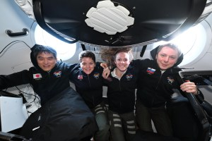](https://www.nasa.gov/news-release/nasas-spacex-crew-10-to-discuss-station-mission-upcoming-return/)

**[NASA’s SpaceX Crew-10 to Discuss Station Mission, Upcoming Return](https://www.nasa.gov/news-release/nasas-spacex-crew-10-to-discuss-station-mission-upcoming-return/)**

2 min read

Media are invited to hear from NASA’s SpaceX Crew-10 during a news conference beginning at 10:40 a.m. EDT, Friday, July 25, from the International Space Station. NASA astronauts Anne McClain and Nichole Ayers, JAXA (Japan Aerospace Exploration Agency) astronaut Takuya…

News Release

[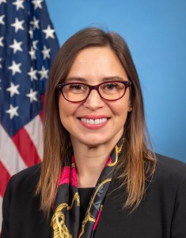](https://www.nasa.gov/news-release/nasa-goddard-center-director-makenzie-lystrup-set-to-depart/)

**[NASA Goddard Center Director Makenzie Lystrup Set to Depart](https://www.nasa.gov/news-release/nasa-goddard-center-director-makenzie-lystrup-set-to-depart/)**

3 min read

On Monday, NASA announced Dr. Makenzie Lystrup, director of NASA’s Goddard Space Flight Center in Greenbelt, Maryland, is set to leave the agency on Friday, Aug. 1. As center director of Goddard, a role she has held since April 2023,…

News Release

[](https://www.nasa.gov/news-release/nasa-invites-media-to-marshalls-65th-anniversary-celebration-july-19/)

**[NASA Invites Media to Marshall’s 65th Anniversary Celebration July 19](https://www.nasa.gov/news-release/nasa-invites-media-to-marshalls-65th-anniversary-celebration-july-19/)**

2 min read

NASA’s Marshall Space Flight Center will host astronauts for a media opportunity as the center celebrates its 65th anniversary during a free, community event on Saturday, July 19, from noon to 5 p.m. CDT at The Orion Amphitheater in Huntsville,…

News Release

[](https://www.nasa.gov/news-release/nasa-to-preview-advanced-us-india-radar-mission-ahead-of-launch/)

**[NASA to Preview Advanced US-India Radar Mission Ahead of Launch](https://www.nasa.gov/news-release/nasa-to-preview-advanced-us-india-radar-mission-ahead-of-launch/)**

3 min read

NASA will host a news conference at 12 p.m. EDT Monday, July 21, to discuss the upcoming NISAR (NASA-ISRO Synthetic Aperture Radar) mission. The Earth-observing satellite, a first-of-its-kind collaboration between NASA and ISRO (Indian Space Research Organisation), carries an advanced…

News Release

[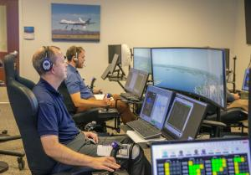](https://www.nasa.gov/news-release/nasa-software-catalog-puts-agency-solutions-at-innovators-fingertips/)

**[NASA Software Catalog Puts Agency Solutions at Innovators’ Fingertips](https://www.nasa.gov/news-release/nasa-software-catalog-puts-agency-solutions-at-innovators-fingertips/)**

3 min read

NASA’s latest open Software Catalog, released Wednesday, offers more than 1,200 downloadable codes developed by agency engineers that could enable faster solutions to energize the space economy and stimulate American ingenuity. The catalog is part of NASA’s effort to place…

News Release

[](https://www.nasa.gov/news-release/nasa-selects-companies-for-architect-engineer-services-contract/)

**[NASA Selects Companies for Architect-Engineer Services Contract](https://www.nasa.gov/news-release/nasa-selects-companies-for-architect-engineer-services-contract/)**

2 min read

NASA has selected seven companies to assist the agency with architectural and engineering services at multiple agency centers and facilities. The Western Regional Architect-Engineer Services is an indefinite-delivery/indefinite-quantity multiple award contract has a total estimated value not to exceed $75…

News Release

[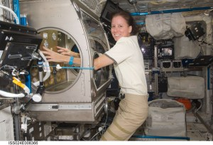](https://www.nasa.gov/news-release/nasa-astronaut-shannon-walker-retires/)

**[NASA Astronaut Shannon Walker Retires](https://www.nasa.gov/news-release/nasa-astronaut-shannon-walker-retires/)**

4 min read

NASA astronaut Shannon Walker retired July 10, concluding a career that spanned 38 years, including 30 years of federal service and more than 21 years as an astronaut. During two spaceflights, she spent 330 days in orbit, contributing to hundreds…

News Release

* Apple
* Dragon fruits
* Kiwi
* mango

[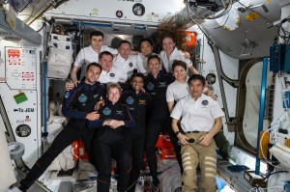](https://www.nasa.gov/news-release/nasa-to-provide-coverage-of-axiom-mission-4-departure-from-station/)

**[NASA to Provide Coverage of Axiom Mission 4 Departure from Station](https://www.nasa.gov/news-release/nasa-to-provide-coverage-of-axiom-mission-4-departure-from-station/)**

3 min rea